

Centrul Teritorial Ploiesti
UNIVERSITATEA “SPIRU HARET”BUCURESTI
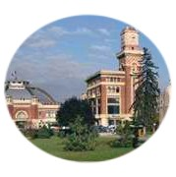
“Let’s do it creatively for the benefit of adult learners”
LEARNING TO LEARN – TEACHING FOREIGN LANGUAGES - DIGITAL SKILLS
31st March – 3rd April 2011

