THE DORMANT SEED by Aidan Cooper

Prior to planting the seed, soil should be dug over and Organic Manure should be added. There are two types of seed, which are Angiosperm which develop into mostly flowering plants, or Gymnosperms which are leafy plants that are mostly conifericious.

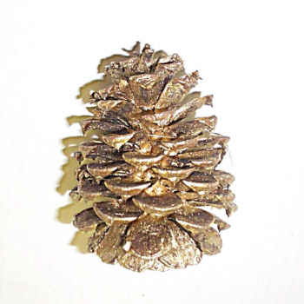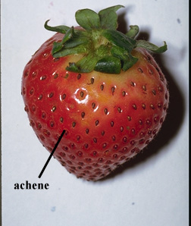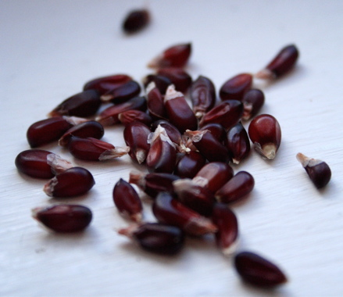

Some seeds require special conditions to break their dormancy (Dodonut) broken by a turkey bird, or heat as in many fires in Australia which are deliberately started to promote seed/plant growth.
Other seeds require different treatments, ie: soaking in water overnight prior to planting in the ground or seed trays, or by simply rubbing seed coat (Testa) with an abrasive material because otherwise the seed coat is too tough for the cotyledon/s to break through.

Breaking Seed Dormancy

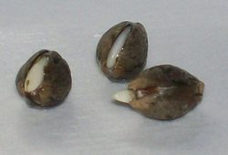

There are two types of germination. These are EPIGEAL when the cotyledon appears from the base of the seed, and HYPOGEAL when the cotyledon appears from the top of the seed.

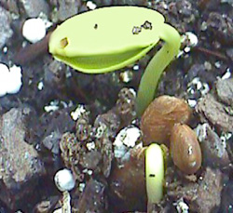

When the cotyledons appear above ground they develop leaf shapes which are either Monocotyledon (one seed leaf) as in grasses and palms, or dicotyledon (two seed leafs) which occurs in most other plants. The growth process can be speeded up and/or stimulated with the addition of sulphate of ammonia as a liquid fertilizer

Plant Growth
Usually after several weeks, or can be several months after the cotyledons have appeared above ground the plant should be strong enough and developed enough to begin flowering. This is usually when Sulphate of potash can be applied as a liquid fertilizer to encourage flowering and/or the production of fruit.
When the first fruit has developed feeding with Sulphate of Ammonia can be repeated usually weekly. However if organic manure has been dug into the soil prior to planting of the seed the addition of any fertilizer is usually unnecessary.
Superphospate can be dug into the soil before planting seed potatoes to encourage a larger crop production. If planting potatoes in February they should be dug up after they have flowered and the flowers have died. Or in the case of second earlies or main crop potatoes they should be harvested when they flower.

After the removal of the potatoes the ground should be weeded and turned over and left fallow until planting in the spring. Unless you are using a system of crop rotation and/or putting a shelter up to create a microclimate to protect tender plants over winter, when planting can sometimes be continued throughout the year, ie: tomato and strawberry plant.

