From oil to soap
Know-how learning making homemade soap
By Olga Martín Cobos (Centro de Adultos, Cáceres, SPAIN)
If we take a usual element from real world such as oil and we look at it from the environmental point of view, we can open different fields of knowledge to which students can get through discovery.
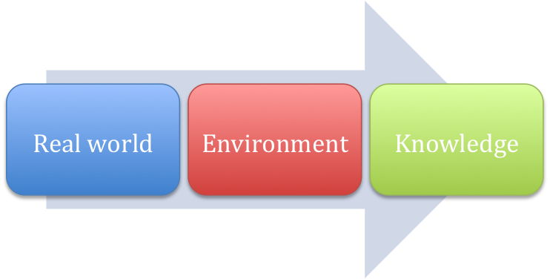
This activity consists of making homemade soap with the students. The starting point is the fact that oil is a basic ingredient in Mediterranean diet. As a residue, it is difficult to be destroyed and it pollutes a lot, specially water. To be recycled, it is necessary to collect oil separately in special containers; in this sense, many campaigns have been done in order to encourage their use. An easy way of reusing oil is collecting it at home and making soap for different uses such as toilet soap, washing machine, cosmetic and therapeutic.
Photo 1: oil home recipient
Photo 2: oil street container
As a teacher in the school knows how to do it and has all the necessary utensils, we take advantage of that and Julia was the activity coordinator; besides, Jose Antonio was the boxes making activity coordinator, but we all make a little part in a joyful, cooperative and creative task; then, we all help.
The magic recipe
If we mix creativity with a spoonful of innovation and a pinch of entrepreneurship, we obtain a good charge of motivation and use it to do almost everything, learning by making, introducing real world in the classroom, encouraging participation and emphasizing authentic materials in teaching.
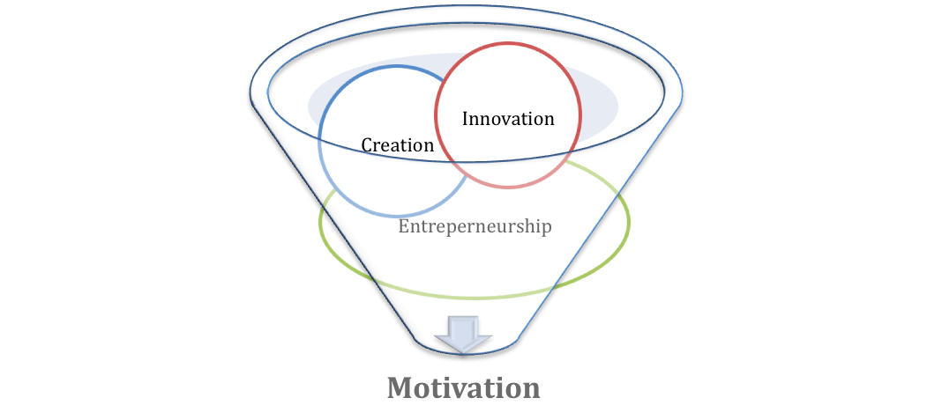
Integration of subjects
This activity is very complete because it integrates different subjects such as:
- Mathematics: it is necessary to calculate proportions.
- Chemistry: students can see directly how ingredients interact.
- Science: we bear in mind a demanding problem such as the effect oil makes on environment and we disseminate the benefits of using homemade soap.
- Arts and design: students can make their own designs, creating forms, colours, for the pieces of soap and for the wraps.
- History: when researching on the origins and cultural spreading of soap.
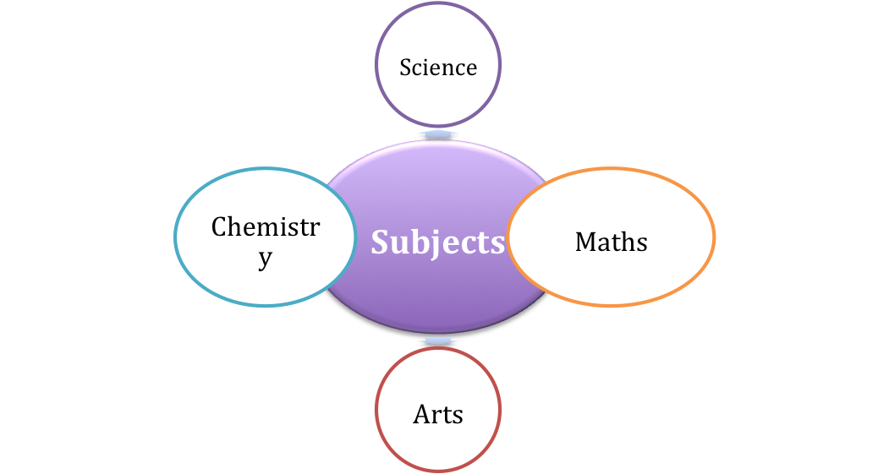
Key competences
If we consider that the important thing in this activity is the knowledge based on know-how as the capability of performing certain tasks, we find the following domains of key competencies:

• communication in the mother tongue: because it is important to read instructions carefully and follow them strictly to get the right result.
• communication in foreign languages: because the leaflet is translated into English.
• ICT: because the students make the edition of the leaflet.
• numeracy and competencies in maths, science and technology: because it is necessary to calculate proportion, to know ingredients and how they interact; besides, environment is a key topic in this activity.
• entrepreneurship: because any of us can make soap by ourselves and add our personal contribution.
• interpersonal and civic competencies: because students have to follow instructions given by a coordinator who leads the process.
• general culture: because traditional wisdom is spread an cultural awareness is awaken.
Procedure
To motivate the students, we showed them ready made soap and proposed them to make their own soap; so they have to get used oil at home. The school got the rest of the material.
One day, we showed them the process of making soap. Soap is made by chemical reaction. Basically, soap is made from combining an acid (oil/s) and an alkali (sodium hydroxide) in precise proportions (saponification). Saponifiable substances are those that can be converted into soap. In hand made soap Glycerin is obtained by the saponification procedure and offers superb moisturizing effect. It is a product obtained naturally. The commercial soap manufacturers conveniently eliminate glycerin when manufacturing soap. Handmade soap has an advantage in the sense that glycerin is not removed from the soap and hence it lends a moisturizing effect.
The process was implemented following the instructions and we left time to do the rest. We spent some weeks waiting for the results. When the soap was ready, it was taken out the moulds and we started to make the packets.

In order to have instructions and materials easily registered, we made a simple dissemination leaflet. This piece of paper was copied and put into the packets as a nice complement of the activity. Another group of students was in charge of translating into English.
The last stage was making the wraps and showing the results to everybody.
Photo 5: instructions leaflet in PDF (2 pages)

